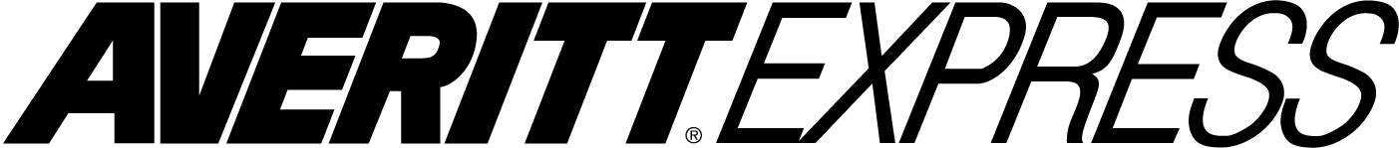DISCIPLINARY FORM

Date:___________________________________________ Service Center:______________________________

Associate:_______________________________________ Position:___________________________________

Last 4 digits SS#__________________________________ Leader:____________________________________

Disciplinary Situation: (please check)

GENERAL CONDUCT

____ D006 Unauthorized use of Co. Property
____ D012 Data System Policy
____ D013 Inappropriate Conduct
____ Profanity/Abusive Language
____ Other: ____________________
____ D017 Uniform/Image Policy
____ D020 Tobacco Policy Violation

ATTENDANCE
____ A004 Leaving work without authorization
____ A005 Failure to follow clock in and out
____ A006 Failure to take lunch as directed

PERFORMANCE ISSUES
____ P001 Unsatisfactory Performance (must check one below) ____ Failure to follow instructions
____ Failure to perform accountabilities
____ Pulled Wrong Trailer
____ Late Pickups/Deliveries
____ Excessive Returns
____ Failure to Collect/sticker CODs
____ Other: _______________________

BILLING ERRORS
____ P002 Billing Errors (must check one below) ____ Data Entry Errors

FREIGHT HANDLING
____ P003 Improper Freight Handling/Prop or Equipment Damage (must check one below
____ Failed to Count Freight
____ Damaged Freight
____ Misloaded Freight
____ Failed to Note Exception
____ Damaging/Loosing a Scanner
____ Misdelivered Freight
____ Paperwork Errors
____ Other: ____________________
BILLING/COD ERROR
____ P004 Billing/COD Error
COMPANY EQUIPMENT
____ CE015 Jamming/Overriding Idle Switch
____ CE016 Driver Behavior Resulting in Locksmith/Jumpstart/Lost Pallet Jack
____ CE017 Modification of Equipment (non-safety related)
____ CE018 Parking at Unauthorized Location (empty)
____ CE019 Unauthorized Pets
____ CE021 Unclean/Unsanitary Tractor
____ HM01 Failure to start/maintain HM/Tanker endorsement

OTHER (as approved by HR)
____ ______ Situation:_________________________

Details: _________________________________________________________________________________________________________

________________________________________________________________________________________________________________

Previous Warnings: Type (oral, written, etc.)

1st warning:________________________________ Date:__________________ By Whom:_______________________

2nd warning:_______________________________ Date:__________________ By Whom:_______________________

3rd warning:_______________________________ Date:__________________ By Whom:_______________________

Current Disciplinary Action: (please check)
____ Oral ____ Written ____ Suspension – Dates:_____________________________

Expectations:____________________________________________________________________________________________________

FutureConsequences:__Disciplinary Action up to and including termination________________________________________________
I have read the Associate Disciplinary Form and understand it.

Meeting held by:______________________________________________________ Date:____________________________

Associate’s signature:__________________________________________________ Date:____________________________

Associate disagrees with this form and refuses to sign above statement.

Reason:_________________________________________________________________________________________________________

Associate’s signature:___________________________________________________ Date:____________________________

Witness:_____________________________________________________________ Date:____________________________

Attach all statements and supporting documents. Forward copy to Human Resources/CSC
HR-F0027 5.21.18

